**Data preprocessing on dataset of Diabetes**

**Masters in computer science(MCS)**

**2019/2020**

**UBIT**

**University of Karachi**

# https://ilm.com.pk/wp-content/uploads/2014/10/University-Of-Karachi-BA-BSC-B.Com-Admission-Schedule-2016.jpg

**Team Members:**

1. Safia Shabbir (P19101062)
2. Erum Saleem (P19101015)
3. Hina Jameel (P19101022)
4. Hina Saeed (P19101023)

## **Introduction**

## **Data Preprocessing**

 Data preprocessing is the process of transforming raw data into an understandable format. It is also an important step in data mining as we cannot work with raw data. The quality of the data should be checked before applying machine learning or data mining algorithms.

## **Why is Data preprocessing important?**

Preprocessing of data is mainly to check the data quality. The quality can be checked by the following

* **Accuracy**: To check whether the data entered is correct or not.
* **Completeness**: To check whether the data is available or not recorded.
* **Consistency:** To check whether the same data is kept in all the places that do or do not match.
* **Timeliness**: The data should be updated correctly.
* **Believability**: The data should be trustable.
* **Interpretability**: The understandability of the data.

## **Major Tasks in Data Preprocessing:**

1. Data cleaning
2. Data integration
3. Data reduction
4. Data transformation

# Data preprocessing

## **Data cleaning:**

Data cleaning is the process to remove incorrect data, incomplete data and inaccurate data from the datasets, and it also replaces the missing values. There are some techniques in data cleaning

### Handling missing values:

* Standard values like “Not Available” or “NA” can be used to replace the missing values.
* Missing values can also be filled manually but it is not recommended when that dataset is big.
* The attribute’s mean value can be used to replace the missing value when the data is normally distributed  
  wherein in the case of non-normal distribution median value of the attribute can be used.
* While using regression or decision tree algorithms the missing value can be replaced by the most probable  
  value.

### Noisy:

### Noisy generally means random error or containing unnecessary data points. Here are some of the methods to handle noisy data.

# **Binning**:

Smoothing by bin mean method

Smoothing by bin median

Smoothing by bin boundary

* **Regression**:

This is used to smooth the data and will help to handle data when unnecessary data is present. For the analysis, purpose regression helps to decide the variable which is suitable for our analysis.

* **Clustering**:

This is used for finding the outliers and also in grouping the data. Clustering is generally used in unsupervised learning.

**Data integration:**

          The process of combining multiple sources into a single dataset. The Data integration process is one of the main components in data management. There are some problems to be considered during data integration.

* Schema integration
* Entity identification problem
* Detecting and resolving data value concepts

**Data reduction:**

 This process helps in the reduction of the volume of the data which makes the analysis easier yet produces the same or almost the same result. This reduction also helps to reduce storage space. There are some of the techniques in data reduction are

* Dimensionality reduction
* Numerosity reduction
* Data compression.

**Data Transformation**:

      The change made in the format or the structure of the data is called data transformation. This step can be simple or complex based on the requirements. There are some methods in data transformation.

* Smoothing
* Aggregation
* Discretization
* Normalization

## **Data preprocessing steps in machine learning**

### Import libraries and the dataset

### Extracting independent variable

### Extracting dependent variable

### Filling the dataset with the mean value of the attribute

### Encoding the country variable

### Dummy encoding

### Encoding for Purchased variable

### Splitting the dataset into training and test set

### Feature Scaling

# **2. Diabetes Dataset**

|  |  |  |  |  |  |  |  |  |
| --- | --- | --- | --- | --- | --- | --- | --- | --- |
| Pregnancies | Glucose | BloodPressure | SkinThickness | Insulin | BMI | DiabetesPedigreeFunction | Age | Outcome |
| 6 |  | 72 |  | 0 | 33.6 | 0.627 | 50 | 1 |
| 1 | 85 | 66 | 29 | 0 | 26.6 | 0.351 | 31 | 0 |
| 8 | 183 | 64 | 0 | 0 | 23.3 | 0.672 | 32 | 1 |
| 1 |  | 66 | 23 | 94 | 28.1 | 0.167 | 21 | 0 |
| 0 | 137 | 40 | 35 | 168 | 43.1 | 2.288 | 33 | 1 |
| 5 | 116 | 74 | 0 | 0 | 25.6 | 0.201 | 30 | 0 |
| 3 | 78 | 50 |  | 88 | 31 | 0.248 | 26 | 1 |
| 10 |  | 0 | 0 | 0 | 35.3 | 0.134 | 29 | 0 |
| 2 | 197 | 70 | 45 | 543 | 30.5 | 0.158 | 53 | 1 |
| 8 | 125 | 96 | 0 | 0 | 0 | 0.232 | 54 | 1 |
| 4 | 110 | 92 | 0 | 0 | 37.6 | 0.191 | 30 | 0 |
| 10 |  | 74 | 0 | 0 | 38 | 0.537 | 34 | 1 |
| 10 | 139 | 80 | 0 | 0 | 27.1 | 1.441 | 57 | 0 |
| 1 |  | 60 |  | 846 | 30.1 | 0.398 | 59 | 1 |
| 5 | 166 | 72 | 19 | 175 | 25.8 | 0.587 | 51 | 1 |
| 7 |  | 0 | 0 | 0 | 30 | 0.484 | 32 | 1 |
| 0 | 118 | 84 | 47 | 230 | 45.8 | 0.551 | 31 | 1 |
| 7 | 107 | 74 | 0 | 0 | 29.6 | 0.254 | 31 | 1 |
| 1 |  | 30 |  | 83 | 43.3 | 0.183 | 33 | 0 |
| 1 | 115 | 70 | 30 | 96 | 34.6 | 0.529 | 32 | 1 |
| 3 |  | 88 |  | 235 | 39.3 | 0.704 | 27 | 0 |
| 8 | 99 | 84 | 0 | 0 | 35.4 | 0.388 | 50 | 0 |
| 7 | 196 | 90 |  | 0 | 39.8 | 0.451 | 41 | 1 |
| 9 |  | 80 | 35 | 0 | 29 | 0.263 | 29 | 1 |
| 11 | 143 | 94 | 33 | 146 | 36.6 | 0.254 | 51 | 1 |
| 10 | 125 | 70 | 26 | 115 | 31.1 | 0.205 | 41 | 1 |
| 7 |  | 76 |  | 0 | 39.4 | 0.257 | 43 | 1 |
| 1 | 97 | 66 | 15 | 140 | 23.2 | 0.487 | 22 | 0 |
| 13 |  | 82 | 19 | 110 | 22.2 | 0.245 | 57 | 0 |
| 5 | 117 | 92 | 0 | 0 | 34.1 | 0.337 | 38 | 0 |
| 5 | 109 | 75 | 26 | 0 | 36 | 0.546 | 60 | 0 |
| 3 |  | 76 |  | 245 | 31.6 | 0.851 | 28 | 1 |
| 3 | 88 | 58 |  | 54 | 24.8 | 0.267 | 22 | 0 |
| 6 |  | 92 | 0 | 0 | 19.9 | 0.188 | 28 | 0 |
| 10 | 122 | 78 | 31 | 0 | 27.6 | 0.512 | 45 | 0 |
| 4 |  | 60 | 33 | 192 | 24 | 0.966 | 33 | 0 |
| 11 | 138 | 76 |  | 0 | 33.2 | 0.42 | 35 | 0 |
| 9 |  | 76 | 37 | 0 | 32.9 | 0.665 | 46 | 1 |
| 2 | 90 | 68 |  | 0 | 38.2 | 0.503 | 27 | 1 |
| 4 | 111 | 72 | 47 | 207 | 37.1 | 1.39 | 56 | 1 |
| 3 |  | 64 | 25 | 70 | 34 | 0.271 | 26 | 0 |
| 7 | 133 | 84 | 0 | 0 | 40.2 | 0.696 | 37 | 0 |
| 7 |  | 92 | 18 | 0 | 22.7 | 0.235 | 48 | 0 |
| 9 | 171 | 110 | 24 | 240 | 45.4 | 0.721 | 54 | 1 |
| 7 |  | 64 | 0 | 0 | 27.4 | 0.294 | 40 | 0 |
| 0 | 180 | 66 |  | 0 | 42 | 1.893 | 25 | 1 |
| 1 | 146 | 56 | 0 | 0 | 29.7 | 0.564 | 29 | 0 |
| 2 |  | 70 | 27 | 0 | 28 | 0.586 | 22 | 0 |
| 7 | 103 | 66 |  | 0 | 39.1 | 0.344 | 31 | 1 |
| 7 | 105 | 0 | 0 | 0 | 0 | 0.305 | 24 | 0 |
| 1 |  | 80 | 11 | 82 | 19.4 | 0.491 | 22 | 0 |
| 1 |  | 50 | 15 | 36 | 24.2 | 0.526 | 26 | 0 |
| 5 | 88 | 66 | 21 | 23 | 24.4 | 0.342 | 30 | 0 |
| 8 |  | 90 | 34 | 300 | 33.7 | 0.467 | 58 | 1 |
| 7 | 150 | 66 | 42 | 342 | 34.7 | 0.718 | 42 | 0 |
| 1 | 73 | 50 | 10 | 0 | 23 | 0.248 | 21 | 0 |
| 7 |  | 68 | 39 | 304 | 37.7 | 0.254 | 41 | 1 |
| 0 | 100 | 88 | 60 | 110 | 46.8 | 0.962 | 31 | 0 |
| 0 | 146 | 82 | 0 | 0 | 40.5 | 1.781 | 44 | 0 |
| 0 | 105 | 64 | 41 | 142 | 41.5 | 0.173 | 22 | 0 |
| 2 |  | 0 | 0 | 0 | 0 | 0.304 | 21 | 0 |
| 8 | 133 | 72 | 0 | 0 | 32.9 | 0.27 | 39 | 1 |
| 5 | 44 | 62 |  | 0 | 25 | 0.587 | 36 | 0 |
| 2 |  | 58 | 34 | 128 | 25.4 | 0.699 | 24 | 0 |
| 7 | 114 | 66 | 0 | 0 | 32.8 | 0.258 | 42 | 1 |
| 5 |  | 74 | 27 | 0 | 29 | 0.203 | 32 | 0 |
| 0 |  | 88 | 30 | 0 | 32.5 | 0.855 | 38 | 1 |
| 2 | 109 | 92 | 0 | 0 | 42.7 | 0.845 | 54 | 0 |
| 1 | 95 | 66 | 13 | 38 | 19.6 | 0.334 | 25 | 0 |
| 4 |  | 85 | 27 | 100 | 28.9 | 0.189 | 27 | 0 |
| 2 | 100 | 66 | 20 | 90 | 32.9 | 0.867 | 28 | 1 |
| 5 | 139 | 64 | 35 | 140 | 28.6 | 0.411 | 26 | 0 |
| 13 | 126 | 90 | 0 | 0 | 43.4 | 0.583 | 42 | 1 |
| 4 |  | 86 | 20 | 270 | 35.1 | 0.231 | 23 | 0 |
| 1 | 79 | 75 |  | 0 | 32 | 0.396 | 22 | 0 |
| 1 | 0 | 48 | 20 | 0 | 24.7 | 0.14 | 22 | 0 |
| 7 | 62 | 78 | 0 | 0 | 32.6 | 0.391 | 41 | 0 |
| 5 |  | 72 |  | 0 | 37.7 | 0.37 | 27 | 0 |
| 0 | 131 | 0 | 0 | 0 | 43.2 | 0.27 | 26 | 1 |
| 2 |  | 66 | 22 | 0 | 25 | 0.307 | 24 | 0 |
| 3 | 113 | 44 | 13 | 0 | 22.4 | 0.14 | 22 | 0 |
| 2 | 74 | 0 | 0 | 0 | 0 | 0.102 | 22 | 0 |
| 7 |  | 78 | 26 | 71 | 29.3 | 0.767 | 36 | 0 |
| 0 | 101 | 65 |  | 0 | 24.6 | 0.237 | 22 | 0 |
| 5 | 137 | 108 | 0 | 0 | 48.8 | 0.227 | 37 | 1 |
| 2 |  | 74 |  | 125 | 32.4 | 0.698 | 27 | 0 |
| 13 | 106 | 72 |  | 0 | 36.6 | 0.178 | 45 | 0 |
| 2 |  | 68 | 25 | 71 | 38.5 | 0.324 | 26 | 0 |
| 15 | 136 | 70 | 32 | 110 | 37.1 | 0.153 | 43 | 1 |
| 1 |  | 68 | 19 | 0 | 26.5 | 0.165 | 24 | 0 |
| 1 | 80 | 55 | 0 | 0 | 19.1 | 0.258 | 21 | 0 |
| 4 | 123 | 80 | 15 | 176 | 32 | 0.443 | 34 | 0 |
| 7 |  | 78 | 40 | 48 | 46.7 | 0.261 | 42 | 0 |
| 4 | 134 | 72 | 0 | 0 | 23.8 | 0.277 | 60 | 1 |
| 2 |  | 82 | 18 | 64 | 24.7 | 0.761 | 21 | 0 |
| 6 |  | 72 |  | 228 | 33.9 | 0.255 | 40 | 0 |
| 2 | 92 | 62 | 28 | 0 | 31.6 | 0.13 | 24 | 0 |
| 1 | 71 | 48 |  | 76 | 20.4 | 0.323 | 22 | 0 |
| 6 | 93 | 50 | 30 | 64 | 28.7 | 0.356 | 23 | 0 |
| 1 |  | 90 | 51 | 220 | 49.7 | 0.325 | 31 | 1 |
| 1 | 163 | 72 |  | 0 | 39 | 1.222 | 33 | 1 |
| 1 | 151 | 60 |  | 0 | 26.1 | 0.179 | 22 | 0 |
| 0 |  | 96 |  | 0 | 22.5 | 0.262 | 21 | 0 |
| 1 |  | 72 |  | 40 | 26.6 | 0.283 | 24 | 0 |
| 2 | 85 | 65 | 0 | 0 | 39.6 | 0.93 | 27 | 0 |
| 1 | 126 | 56 | 29 | 152 | 28.7 | 0.801 | 21 | 0 |
| 1 | 96 | 122 | 0 | 0 | 22.4 | 0.207 | 27 | 0 |
| 4 |  | 58 | 28 | 140 | 29.5 | 0.287 | 37 | 0 |
| 3 | 83 | 58 | 31 | 18 | 34.3 | 0.336 | 25 | 0 |
| 0 | 95 | 85 |  | 36 | 37.4 | 0.247 | 24 | 1 |
| 3 |  | 72 |  | 135 | 33.3 | 0.199 | 24 | 1 |
| 8 |  | 62 | 26 | 495 | 34 | 0.543 | 46 | 1 |
| 1 | 89 | 76 | 34 | 37 | 31.2 | 0.192 | 23 | 0 |
| 4 | 76 | 62 | 0 | 0 | 34 | 0.391 | 25 | 0 |
| 7 | 160 | 54 |  | 175 | 30.5 | 0.588 | 39 | 1 |
| 4 | 146 | 92 | 0 | 0 | 31.2 | 0.539 | 61 | 1 |
| 5 |  | 74 | 0 | 0 | 34 | 0.22 | 38 | 1 |
| 5 | 78 | 48 | 0 | 0 | 33.7 | 0.654 | 25 | 0 |
| 4 | 97 | 60 | 23 | 0 | 28.2 | 0.443 | 22 | 0 |
| 4 | 99 | 76 |  | 51 | 23.2 | 0.223 | 21 | 0 |
| 0 | 162 | 76 | 56 | 100 | 53.2 | 0.759 | 25 | 1 |
| 6 |  | 64 | 39 | 0 | 34.2 | 0.26 | 24 | 0 |
| 2 |  | 74 | 30 | 100 | 33.6 | 0.404 | 23 | 0 |
| 5 | 132 | 80 |  | 0 | 26.8 | 0.186 | 69 | 0 |
| 0 | 113 | 76 | 0 | 0 | 33.3 | 0.278 | 23 | 1 |
| 1 | 88 | 30 | 42 | 99 | 55 | 0.496 | 26 | 1 |
| 3 | 120 | 70 | 30 | 135 | 42.9 | 0.452 | 30 | 0 |
| 1 | 118 | 58 |  | 94 | 33.3 | 0.261 | 23 | 0 |
| 1 |  | 88 |  | 145 | 34.5 | 0.403 | 40 | 1 |
| 0 | 105 | 84 | 0 | 0 | 27.9 | 0.741 | 62 | 1 |
| 4 | 173 | 70 |  | 168 | 29.7 | 0.361 | 33 | 1 |
| 9 | 122 | 56 | 0 | 0 | 33.3 | 1.114 | 33 | 1 |
| 3 | 170 | 64 | 37 | 225 | 34.5 | 0.356 | 30 | 1 |
| 8 | 84 | 74 | 31 | 0 | 38.3 | 0.457 | 39 | 0 |
| 2 | 96 | 68 | 13 | 49 | 21.1 | 0.647 | 26 | 0 |
| 2 | 125 | 60 |  | 140 | 33.8 | 0.088 | 31 | 0 |
| 0 |  | 70 | 26 | 50 | 30.8 | 0.597 | 21 | 0 |
| 0 | 93 | 60 | 25 | 92 | 28.7 | 0.532 | 22 | 0 |
| 0 | 129 | 80 | 0 | 0 | 31.2 | 0.703 | 29 | 0 |
| 5 |  | 72 | 29 | 325 | 36.9 | 0.159 | 28 | 0 |
| 3 | 128 | 78 | 0 | 0 | 21.1 | 0.268 | 55 | 0 |
| 5 |  | 82 | 30 | 0 | 39.5 | 0.286 | 38 | 0 |
| 2 | 108 | 52 |  | 63 | 32.5 | 0.318 | 22 | 0 |
| 10 | 108 | 66 | 0 | 0 | 32.4 | 0.272 | 42 | 1 |
| 4 | 154 | 62 |  | 284 | 32.8 | 0.237 | 23 | 0 |
| 0 | 102 | 75 | 23 | 0 | 0 | 0.572 | 21 | 0 |
| 9 | 57 | 80 | 37 | 0 | 32.8 | 0.096 | 41 | 0 |
| 2 |  | 64 |  | 119 | 30.5 | 1.4 | 34 | 0 |
| 5 | 147 | 78 | 0 | 0 | 33.7 | 0.218 | 65 | 0 |
| 2 |  | 70 | 17 | 0 | 27.3 | 0.085 | 22 | 0 |
| 1 | 136 | 74 |  | 204 | 37.4 | 0.399 | 24 | 0 |
| 4 | 114 | 65 | 0 | 0 | 21.9 | 0.432 | 37 | 0 |
| 9 |  | 86 | 28 | 155 | 34.3 | 1.189 | 42 | 1 |
| 1 | 153 | 82 |  | 485 | 40.6 | 0.687 | 23 | 0 |
| 8 |  | 78 | 0 | 0 | 47.9 | 0.137 | 43 | 1 |
| 7 | 152 | 88 |  | 0 | 50 | 0.337 | 36 | 1 |
| 2 | 99 | 52 | 15 | 94 | 24.6 | 0.637 | 21 | 0 |
| 1 |  | 56 | 21 | 135 | 25.2 | 0.833 | 23 | 0 |
| 2 | 88 | 74 |  | 53 | 29 | 0.229 | 22 | 0 |
| 17 |  | 72 | 41 | 114 | 40.9 | 0.817 | 47 | 1 |
| 4 | 151 | 90 | 38 | 0 | 29.7 | 0.294 | 36 | 0 |
| 7 | 102 | 74 | 40 | 105 | 37.2 | 0.204 | 45 | 0 |
| 0 |  | 80 | 34 | 285 | 44.2 | 0.167 | 27 | 0 |
| 2 | 100 | 64 | 23 | 0 | 29.7 | 0.368 | 21 | 0 |
| 0 | 131 | 88 | 0 | 0 | 31.6 | 0.743 | 32 | 1 |
| 6 | 104 | 74 | 18 | 156 | 29.9 | 0.722 | 41 | 1 |
| 3 | 148 | 66 | 25 | 0 | 32.5 | 0.256 | 22 | 0 |
| 4 | 120 | 68 | 0 | 0 | 29.6 | 0.709 | 34 | 0 |
| 4 | 110 | 66 | 0 | 0 | 31.9 | 0.471 | 29 | 0 |
| 3 | 111 | 90 | 12 | 78 | 28.4 | 0.495 | 29 | 0 |
| 6 | 102 | 82 | 0 | 0 | 30.8 | 0.18 | 36 | 1 |
| 6 | 134 | 70 | 23 | 130 | 35.4 | 0.542 | 29 | 1 |
| 2 | 87 | 0 | 23 | 0 | 28.9 | 0.773 | 25 | 0 |
| 1 | 79 | 60 | 42 | 48 | 43.5 | 0.678 | 23 | 0 |
| 2 | 75 | 64 | 24 | 55 | 29.7 | 0.37 | 33 | 0 |
| 8 | 179 | 72 | 42 | 130 | 32.7 | 0.719 | 36 | 1 |
| 6 | 85 | 78 | 0 | 0 | 31.2 | 0.382 | 42 | 0 |
| 0 | 129 | 110 | 46 | 130 | 67.1 | 0.319 | 26 | 1 |
| 5 | 143 | 78 | 0 | 0 | 45 | 0.19 | 47 | 0 |
| 5 | 130 | 82 | 0 | 0 | 39.1 | 0.956 | 37 | 1 |
| 6 | 87 | 80 | 0 | 0 | 23.2 | 0.084 | 32 | 0 |
| 0 | 119 | 64 | 18 | 92 | 34.9 | 0.725 | 23 | 0 |
| 1 | 0 | 74 | 20 | 23 | 27.7 | 0.299 | 21 | 0 |
| 5 | 73 | 60 | 0 | 0 | 26.8 | 0.268 | 27 | 0 |
| 4 | 141 | 74 | 0 | 0 | 27.6 | 0.244 | 40 | 0 |
| 7 | 194 | 68 | 28 | 0 | 35.9 | 0.745 | 41 | 1 |
| 8 | 181 | 68 | 36 | 495 | 30.1 | 0.615 | 60 | 1 |
| 1 | 128 | 98 | 41 | 58 | 32 | 1.321 | 33 | 1 |
| 8 | 109 | 76 | 39 | 114 | 27.9 | 0.64 | 31 | 1 |
| 5 | 139 | 80 | 35 | 160 | 31.6 | 0.361 | 25 | 1 |
| 3 | 111 | 62 | 0 | 0 | 22.6 | 0.142 | 21 | 0 |
| 9 | 123 | 70 | 44 | 94 | 33.1 | 0.374 | 40 | 0 |
| 7 | 159 | 66 | 0 | 0 | 30.4 | 0.383 | 36 | 1 |
| 11 | 135 | 0 | 0 | 0 | 52.3 | 0.578 | 40 | 1 |
| 8 | 85 | 55 | 20 | 0 | 24.4 | 0.136 | 42 | 0 |
| 5 | 158 | 84 | 41 | 210 | 39.4 | 0.395 | 29 | 1 |
| 1 | 105 | 58 | 0 | 0 | 24.3 | 0.187 | 21 | 0 |
| 3 | 107 | 62 | 13 | 48 | 22.9 | 0.678 | 23 | 1 |
| 4 | 109 | 64 | 44 | 99 | 34.8 | 0.905 | 26 | 1 |
| 4 | 148 | 60 | 27 | 318 | 30.9 | 0.15 | 29 | 1 |
| 0 | 113 | 80 | 16 | 0 | 31 | 0.874 | 21 | 0 |
| 1 | 138 | 82 | 0 | 0 | 40.1 | 0.236 | 28 | 0 |
| 0 | 108 | 68 | 20 | 0 | 27.3 | 0.787 | 32 | 0 |
| 2 | 99 | 70 | 16 | 44 | 20.4 | 0.235 | 27 | 0 |
| 6 | 103 | 72 | 32 | 190 | 37.7 | 0.324 | 55 | 0 |
| 5 | 111 | 72 | 28 | 0 | 23.9 | 0.407 | 27 | 0 |
| 8 | 196 | 76 | 29 | 280 | 37.5 | 0.605 | 57 | 1 |
| 5 | 162 | 104 | 0 | 0 | 37.7 | 0.151 | 52 | 1 |
| 1 | 96 | 64 | 27 | 87 | 33.2 | 0.289 | 21 | 0 |
| 7 | 184 | 84 | 33 | 0 | 35.5 | 0.355 | 41 | 1 |
| 2 | 81 | 60 | 22 | 0 | 27.7 | 0.29 | 25 | 0 |
| 0 | 147 | 85 | 54 | 0 | 42.8 | 0.375 | 24 | 0 |
| 7 | 179 | 95 | 31 | 0 | 34.2 | 0.164 | 60 | 0 |
| 0 | 140 | 65 | 26 | 130 | 42.6 | 0.431 | 24 | 1 |
| 9 | 112 | 82 | 32 | 175 | 34.2 | 0.26 | 36 | 1 |
| 12 | 151 | 70 | 40 | 271 | 41.8 | 0.742 | 38 | 1 |
| 5 | 109 | 62 | 41 | 129 | 35.8 | 0.514 | 25 | 1 |
| 6 | 125 | 68 | 30 | 120 | 30 | 0.464 | 32 | 0 |
| 5 | 85 | 74 | 22 | 0 | 29 | 1.224 | 32 | 1 |
| 5 | 112 | 66 | 0 | 0 | 37.8 | 0.261 | 41 | 1 |
| 0 | 177 | 60 | 29 | 478 | 34.6 | 1.072 | 21 | 1 |
| 2 | 158 | 90 | 0 | 0 | 31.6 | 0.805 | 66 | 1 |
| 7 | 119 | 0 | 0 | 0 | 25.2 | 0.209 | 37 | 0 |
| 7 | 142 | 60 | 33 | 190 | 28.8 | 0.687 | 61 | 0 |
| 1 | 100 | 66 | 15 | 56 | 23.6 | 0.666 | 26 | 0 |
| 1 | 87 | 78 | 27 | 32 | 34.6 | 0.101 | 22 | 0 |
| 0 | 101 | 76 | 0 | 0 | 35.7 | 0.198 | 26 | 0 |
| 3 | 162 | 52 | 38 | 0 | 37.2 | 0.652 | 24 | 1 |
| 4 | 197 | 70 | 39 | 744 | 36.7 | 2.329 | 31 | 0 |
| 0 | 117 | 80 | 31 | 53 | 45.2 | 0.089 | 24 | 0 |
| 4 | 142 | 86 | 0 | 0 | 44 | 0.645 | 22 | 1 |
| 6 | 134 | 80 | 37 | 370 | 46.2 | 0.238 | 46 | 1 |
| 1 | 79 | 80 | 25 | 37 | 25.4 | 0.583 | 22 | 0 |
| 4 | 122 | 68 | 0 | 0 | 35 | 0.394 | 29 | 0 |
| 3 | 74 | 68 | 28 | 45 | 29.7 | 0.293 | 23 | 0 |
| 4 | 171 | 72 | 0 | 0 | 43.6 | 0.479 | 26 | 1 |
| 7 | 181 | 84 | 21 | 192 | 35.9 | 0.586 | 51 | 1 |
| 0 | 179 | 90 | 27 | 0 | 44.1 | 0.686 | 23 | 1 |
| 9 | 164 | 84 | 21 | 0 | 30.8 | 0.831 | 32 | 1 |
| 0 | 104 | 76 | 0 | 0 | 18.4 | 0.582 | 27 | 0 |
| 1 | 91 | 64 | 24 | 0 | 29.2 | 0.192 | 21 | 0 |
| 4 | 91 | 70 | 32 | 88 | 33.1 | 0.446 | 22 | 0 |
| 3 | 139 | 54 | 0 | 0 | 25.6 | 0.402 | 22 | 1 |
| 6 | 119 | 50 | 22 | 176 | 27.1 | 1.318 | 33 | 1 |
| 2 | 146 | 76 | 35 | 194 | 38.2 | 0.329 | 29 | 0 |
| 9 | 184 | 85 | 15 | 0 | 30 | 1.213 | 49 | 1 |
| 10 | 122 | 68 | 0 | 0 | 31.2 | 0.258 | 41 | 0 |
| 0 | 165 | 90 | 33 | 680 | 52.3 | 0.427 | 23 | 0 |
| 9 | 124 | 70 | 33 | 402 | 35.4 | 0.282 | 34 | 0 |
| 1 | 111 | 86 | 19 | 0 | 30.1 | 0.143 | 23 | 0 |
| 9 | 106 | 52 | 0 | 0 | 31.2 | 0.38 | 42 | 0 |
| 2 | 129 | 84 | 0 | 0 | 28 | 0.284 | 27 | 0 |
| 2 | 90 | 80 | 14 | 55 | 24.4 | 0.249 | 24 | 0 |
| 0 | 86 | 68 | 32 | 0 | 35.8 | 0.238 | 25 | 0 |
| 12 | 92 | 62 | 7 | 258 | 27.6 | 0.926 | 44 | 1 |
| 1 | 113 | 64 | 35 | 0 | 33.6 | 0.543 | 21 | 1 |
| 3 | 111 | 56 | 39 | 0 | 30.1 | 0.557 | 30 | 0 |
| 2 | 114 | 68 | 22 | 0 | 28.7 | 0.092 | 25 | 0 |
| 1 | 193 | 50 | 16 | 375 | 25.9 | 0.655 | 24 | 0 |
| 11 | 155 | 76 | 28 | 150 | 33.3 | 1.353 | 51 | 1 |
| 3 | 191 | 68 | 15 | 130 | 30.9 | 0.299 | 34 | 0 |
| 3 | 141 | 0 | 0 | 0 | 30 | 0.761 | 27 | 1 |
| 4 | 95 | 70 | 32 | 0 | 32.1 | 0.612 | 24 | 0 |
| 3 | 142 | 80 | 15 | 0 | 32.4 | 0.2 | 63 | 0 |
| 4 | 123 | 62 | 0 | 0 | 32 | 0.226 | 35 | 1 |
| 5 | 96 | 74 | 18 | 67 | 33.6 | 0.997 | 43 | 0 |
| 0 | 138 | 0 | 0 | 0 | 36.3 | 0.933 | 25 | 1 |
| 2 | 128 | 64 | 42 | 0 | 40 | 1.101 | 24 | 0 |
| 0 | 102 | 52 | 0 | 0 | 25.1 | 0.078 | 21 | 0 |
| 2 | 146 | 0 | 0 | 0 | 27.5 | 0.24 | 28 | 1 |
| 10 | 101 | 86 | 37 | 0 | 45.6 | 1.136 | 38 | 1 |
| 2 | 108 | 62 | 32 | 56 | 25.2 | 0.128 | 21 | 0 |
| 3 | 122 | 78 | 0 | 0 | 23 | 0.254 | 40 | 0 |
| 1 | 71 | 78 | 50 | 45 | 33.2 | 0.422 | 21 | 0 |
| 13 | 106 | 70 |  | 0 | 34.2 | 0.251 | 52 | 0 |
| 2 | 100 | 70 | 52 | 57 | 40.5 | 0.677 | 25 | 0 |
| 7 | 106 | 60 | 24 | 0 | 26.5 | 0.296 | 29 | 1 |
| 0 | 104 | 64 | 23 | 116 | 27.8 | 0.454 | 23 | 0 |
| 5 | 114 | 74 | 0 | 0 | 24.9 | 0.744 | 57 | 0 |
| 2 | 108 | 62 |  | 278 | 25.3 | 0.881 | 22 | 0 |
| 0 | 146 | 70 | 0 | 0 | 37.9 | 0.334 | 28 | 1 |
| 10 | 129 | 76 | 28 | 122 | 35.9 | 0.28 | 39 | 0 |
| 7 | 133 | 88 | 15 | 155 | 32.4 | 0.262 | 37 | 0 |
| 7 | 161 | 86 |  | 0 | 30.4 | 0.165 | 47 | 1 |
| 2 | 108 | 80 | 0 | 0 | 27 | 0.259 | 52 | 1 |
| 7 | 136 | 74 |  | 135 | 26 | 0.647 | 51 | 0 |
| 5 | 155 | 84 | 44 | 545 | 38.7 | 0.619 | 34 | 0 |
| 1 | 119 | 86 | 39 | 220 | 45.6 | 0.808 | 29 | 1 |
| 4 | 96 | 56 | 17 | 49 | 20.8 | 0.34 | 26 | 0 |
| 5 | 108 | 72 | 43 | 75 | 36.1 | 0.263 | 33 | 0 |
| 0 | 78 | 88 | 29 | 40 | 36.9 | 0.434 | 21 | 0 |
| 0 | 107 | 62 | 30 | 74 | 36.6 | 0.757 | 25 | 1 |
| 2 | 128 | 78 | 37 | 182 | 43.3 | 1.224 | 31 | 1 |
| 1 | 128 | 48 | 45 | 194 | 40.5 | 0.613 | 24 | 1 |
| 0 | 161 | 50 | 0 | 0 | 21.9 | 0.254 | 65 | 0 |
| 6 | 151 | 62 | 31 | 120 | 35.5 | 0.692 | 28 | 0 |
| 2 | 146 | 70 | 38 | 360 | 28 | 0.337 | 29 | 1 |
| 0 | 126 | 84 | 29 | 215 | 30.7 | 0.52 | 24 | 0 |
| 14 | 100 | 78 | 25 | 184 | 36.6 | 0.412 | 46 | 1 |

**About this dataset**

**Context**

This dataset is originally from the National Institute of Diabetes and Digestive and Kidney Diseases. The objective is to predict based on diagnostic measurements whether a patient has diabetes.

### Content

Several constraints were placed on the selection of these instances from a larger database. In particular, all patients here are females at least 21 years old of Pima Indian heritage.

* Pregnancies: Number of times pregnant
* Glucose: Plasma glucose concentration a 2 hours in an oral glucose tolerance test
* BloodPressure: Diastolic blood pressure (mm Hg)
* SkinThickness: Triceps skin fold thickness (mm)
* Insulin: 2-Hour serum insulin (mu U/ml)
* BMI: Body mass index (weight in kg/(height in m)^2)
* DiabetesPedigreeFunction: Diabetes pedigree function
* Age: Age (years)
* Outcome: Class variable (0 or 1)

#### Sources:

(a) Original owners: National Institute of Diabetes and Digestive and  
Kidney Diseases  
(b) Donor of database: Vincent Sigillito (vgs@aplcen.apl.jhu.edu)  
Research Center, RMI Group Leader  
Applied Physics Laboratory  
The Johns Hopkins University  
Johns Hopkins Road  
Laurel, MD 20707  
(301) 953-6231  
(c) Date received: 9 May 1990

#### Number of Instances: 300

#### Number of Attributes: 8 plus class

#### For Each Attribute: (all numeric-valued)

1. Number of times pregnant
2. Plasma glucose concentration a 2 hours in an oral glucose tolerance test
3. Diastolic blood pressure (mm Hg)
4. Triceps skin fold thickness (mm)
5. 2-Hour serum insulin (mu U/ml)
6. Body mass index (weight in kg/(height in m)^2)
7. Diabetes pedigree function
8. Age (years)
9. Class variable (0 or 1)

#### Missing Attribute Values: Yes

#### Class Distribution: (class value 1 is interpreted as "tested positive for diabetes")

#### **3. Data mining/ analytics/visualisation.**

#### **Coding**

library(RSQLite)

library(DBI)

library(datasets)

library(caTools)

library(e1071)

c<-file.choose("diab1.csv")

mydata<-read.csv(c)

datasetss<-read.csv(c)

#mydata<-read.csv(file = "/home/spllab01/Diabetes/diab1.csv",header = TRUE,sep = ",")

#datasetss<-read.csv(file = "/home/spllab01/Diabetes/diab1.csv",header = TRUE,sep = ",")

View(mydata)

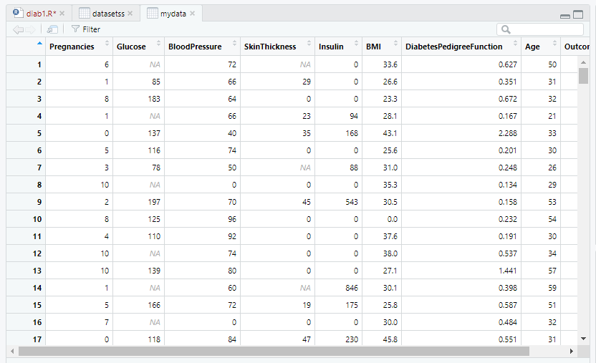

View(datasetss)

#dataset<-read.table('diab.csv',header = T)

datasetss$SkinThickness = ifelse(is.na(dataset$SkinThickness), ave(dataset$SkinThickness, FUN = function(x) mean(x, na.rm = 'TRUE')), dataset$SkinThickness)

#Fills the NUll values with the average of that column values.

View(datasetss)

datasetss$Glucose = ifelse(is.na(dataset$Glucose), ave(dataset$Glucose, FUN = function(x) mean(x, na.rm = 'TRUE')), dataset$Glucose)

View(datasetss)

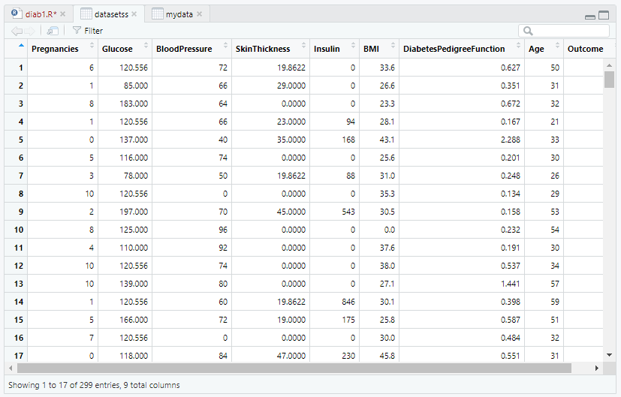

h<-hist(datasetss$SkinThickness,main="Skin Thickness frquencies - histogram", xlab = "Skin Thickness", xlim = c(5,50),col = "blue")

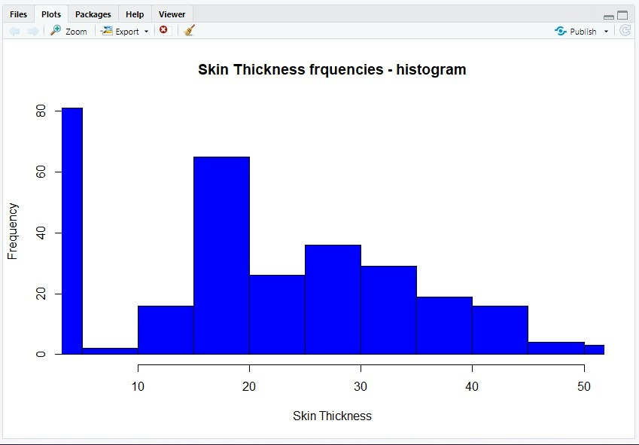

h<-hist(datasetss$Glucose,main="Glucose frquencies - histogram", xlab = "Glucose Value",col = "blue",labels = TRUE, breaks = 8, border = "green",las=3)

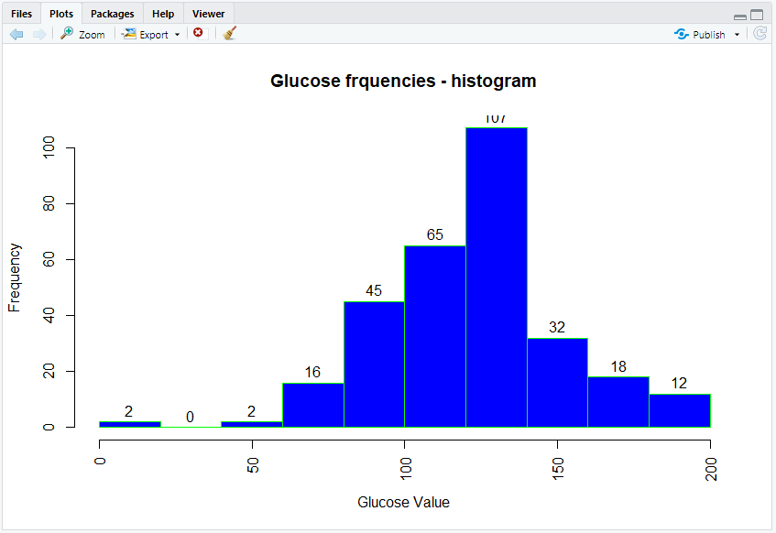

train<-as.data.frame(datasetss[1:200,])

View(train)

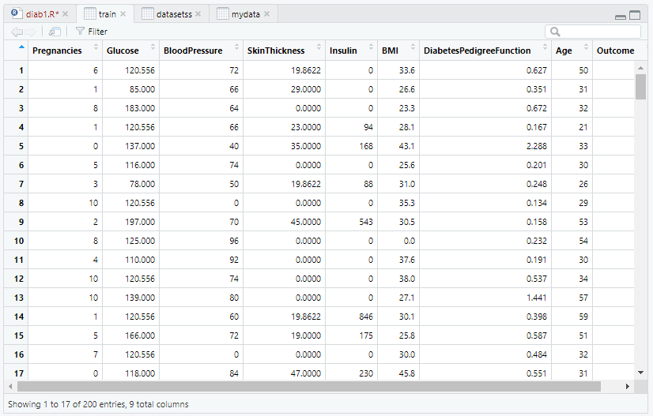

test<-as.data.frame(datasetss[201:299,])

View(test)

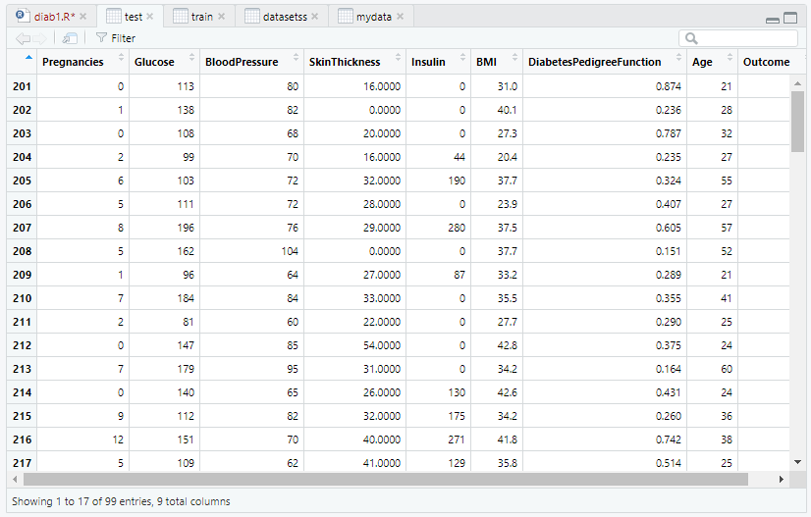

head(train)

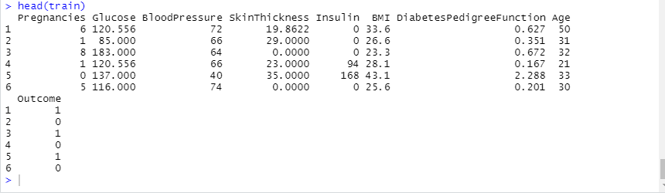

head(test)

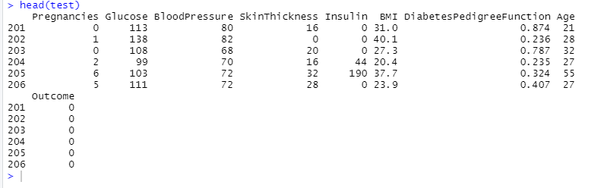

my_model<-naiveBayes(as.factor(train$Outcome)~.,train)

pred1<-predict(my_model,test[,-9])

pred1

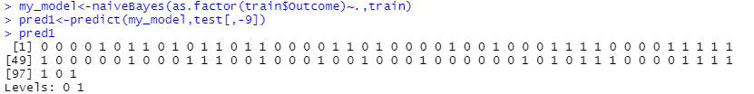

#generate the confusion matrix

table(pred1,test$Outcome,dnn=c("predicted","actual"))

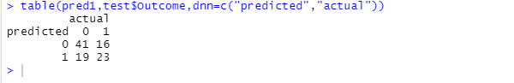

#Build Classifier Models using Different Techniques.

#Cross Validation.

#Cross Validation K fold cross validation

library(caret)

library(lattice)

library(ggplot2)

# Define train control for k fold cross validation

train_control <- trainControl(method="cv", number=10)

# Fit Naive Bayes Model

model <- train(SkinThickness~., data=datasetss, trControl=train_control, method="knn")

# Summarise Results

print(model)

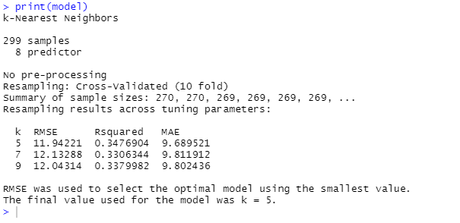

#scatterPolt matrix

head(datasetss)

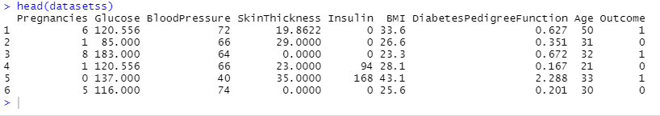

pairs(datasetss[,1:4], pch = 19)

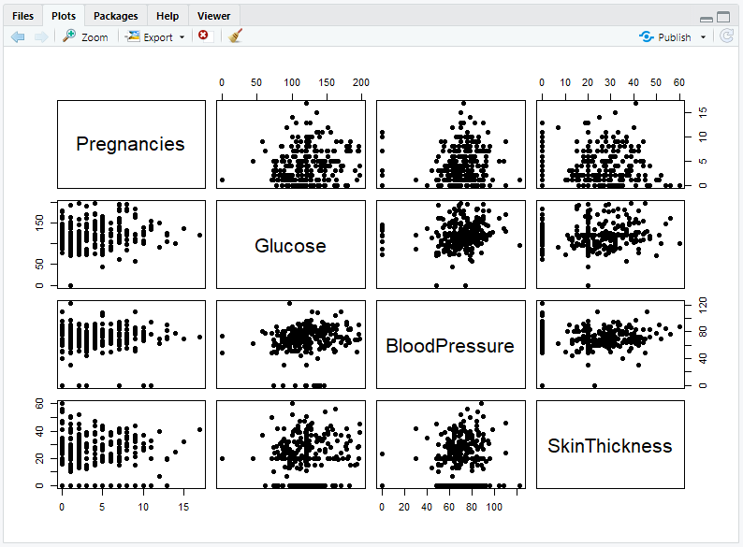

pairs(datasetss[,5:9], pch = 19)

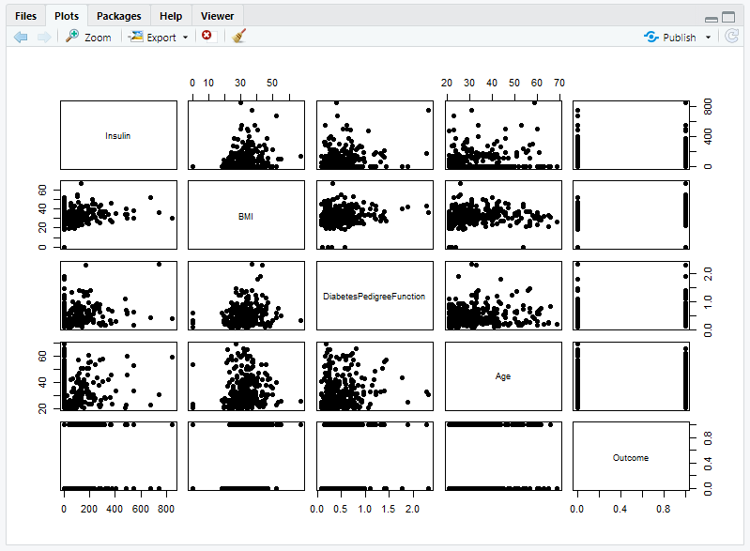

pairs(datasetss[,1:4], pch = 19, lower.panel = NULL)

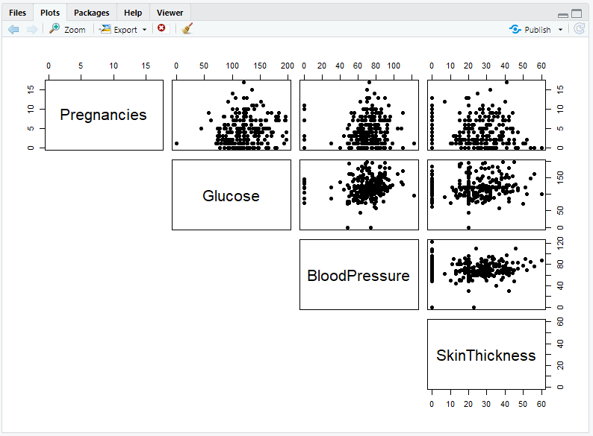

pairs(datasetss[,5:9], pch = 19, lower.panel = NULL)

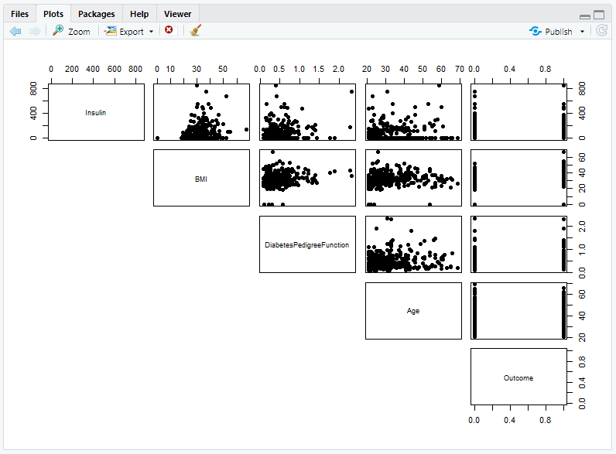

View(datasetss)

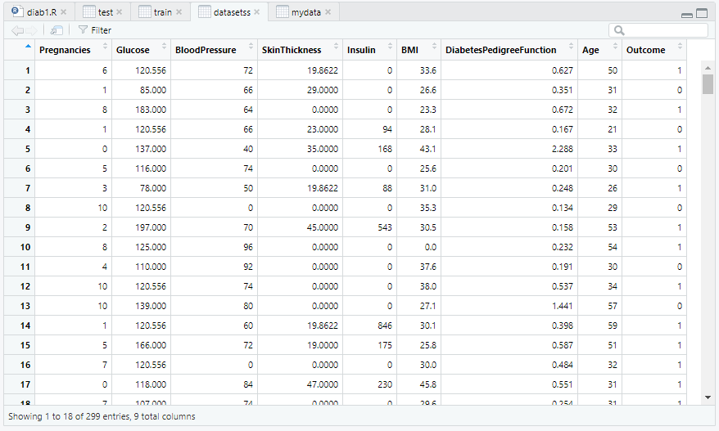

#One more classifier model

library(mlbench)

library(caret)

# prepare training scheme

control <- trainControl(method="repeatedcv", number=10, repeats=3)

# CART

set.seed(7)

fit.cart <- train(SkinThickness~., data=datasetss, method="rpart", trControl=control)

# SVM

set.seed(7)

fit.svm <- train(SkinThickness~., data=datasetss, method="svmRadial", trControl=control)

# kNN

set.seed(7)

fit.knn <- train(SkinThickness~., data=datasetss, method="knn", trControl=control)

# Random Forest

set.seed(7)

fit.rf <- train(SkinThickness~., data=datasetss, method="rf", trControl=control)

# collect resamples

results <- resamples(list(CART=fit.cart, SVM=fit.svm, KNN=fit.knn, RF=fit.rf))

summary(results)

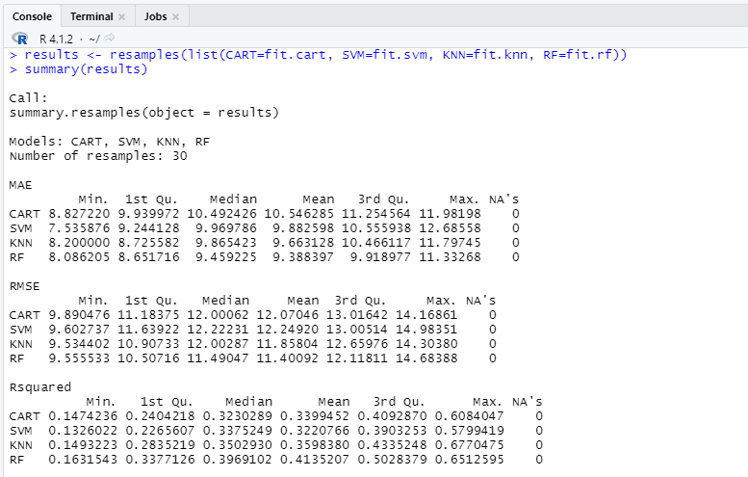

#box wisker

scales <- list(x=list(relation="free"), y=list(relation="free"))

bwplot(results, scales=scales)

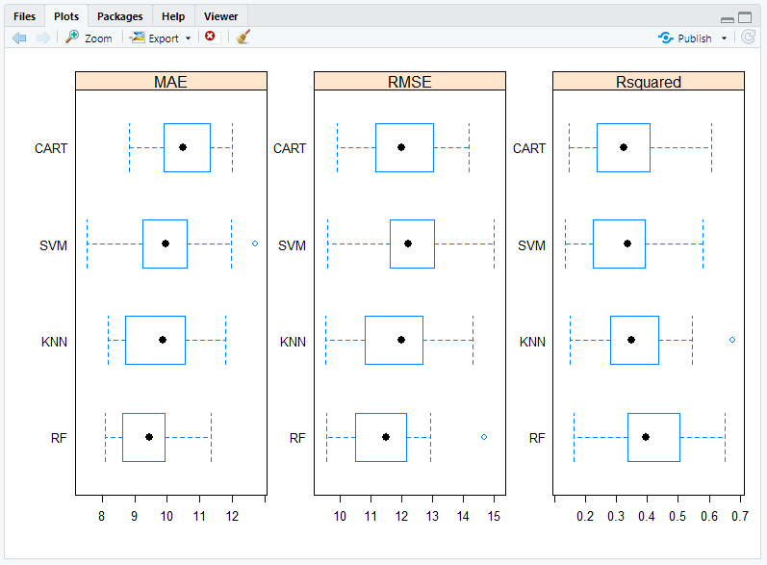

#density plots

scales <- list(x=list(relation="free"), y=list(relation="free"))

densityplot(results, scales=scales, pch = "|")

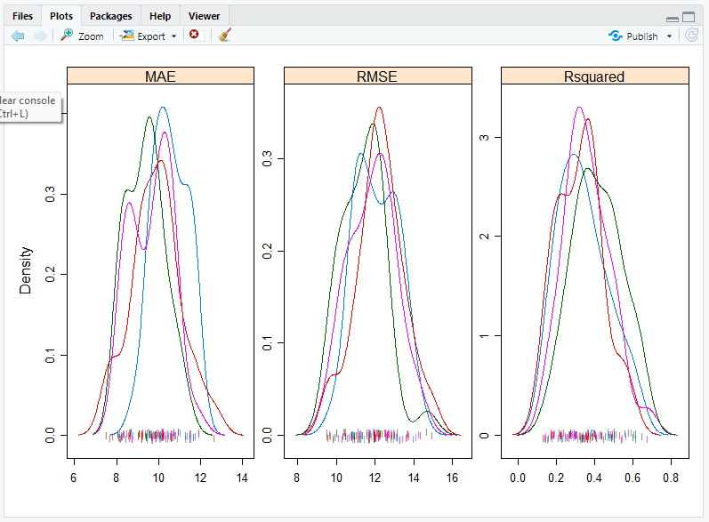

#dot plots

scales <- list(x=list(relation="free"), y=list(relation="free"))

dotplot(results, scales=scales)

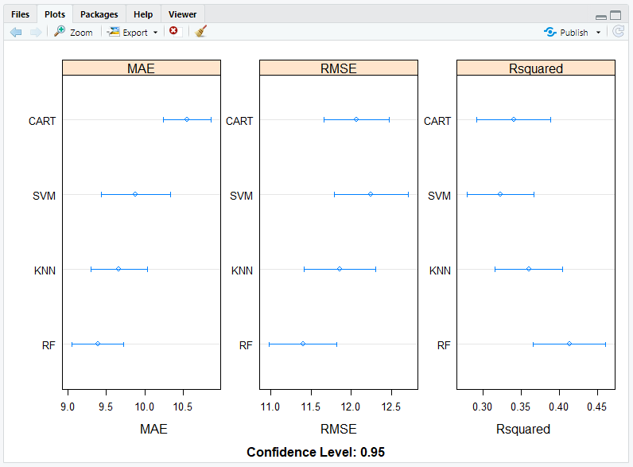

#parallel plots

parallelplot(results)

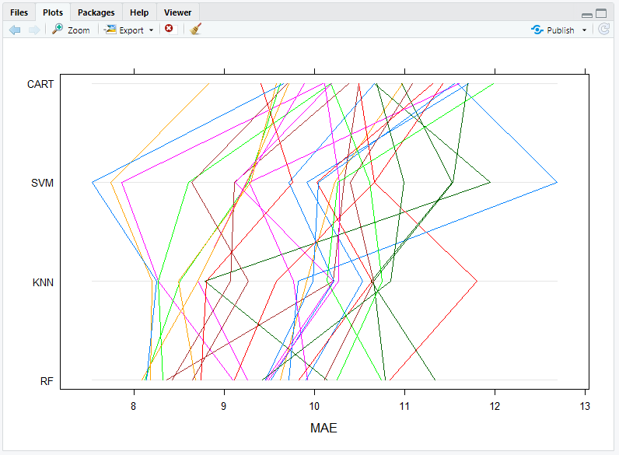

#scatter plot

splom(results)

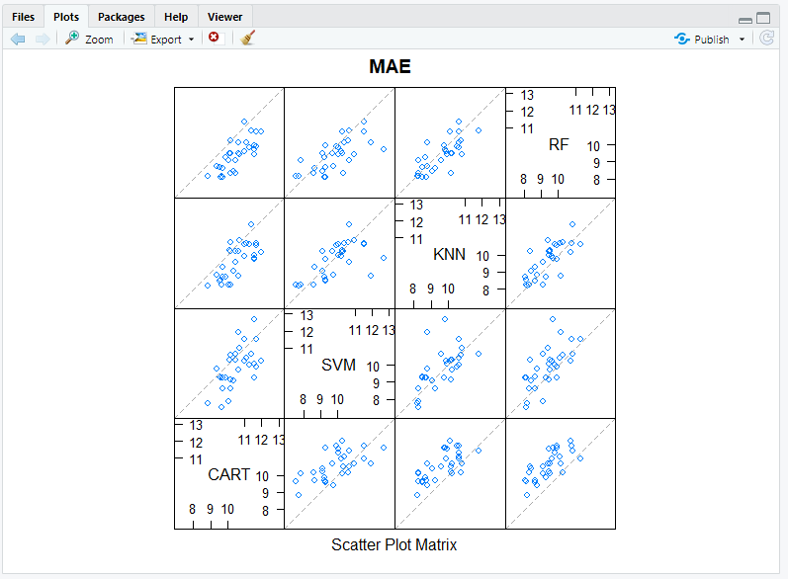

#pair wise x and y plots

xyplot(results, models=c("KNN", "SVM"))

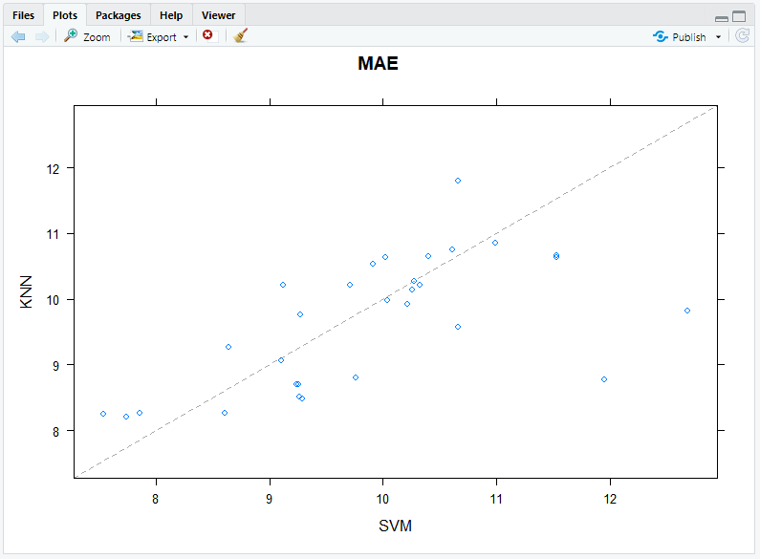

#statisticall significance test

# difference in model predictions

diffs <- diff(results)

# summarize p-values for pair-wise comparisons

summary(diffs)

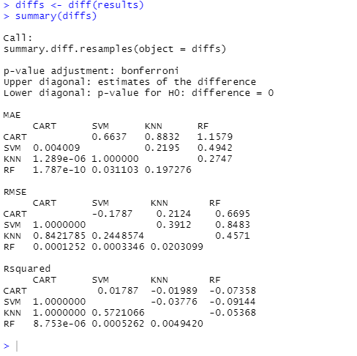

**4. Results and conclusions**

The work done is as follows:

1) Diabetes Data Set read.

2) With Exploring Data Analysis; The structural data of the data set has been checked. Variable types in the data set are examined.

3) Data Preprocessing section; NaN values were filled with missing observations

4) During Modeling; Cross-Validation Score was calculated using machine learning models such as NaiveBayes, KNN, SVM, CART, Random Forests.